- Write a SELECT statement that returns three columns from the Vendors table: VendorContactFName, VendorContactLName, and VendorName. Sort the result set by last name, then by first name.
  - 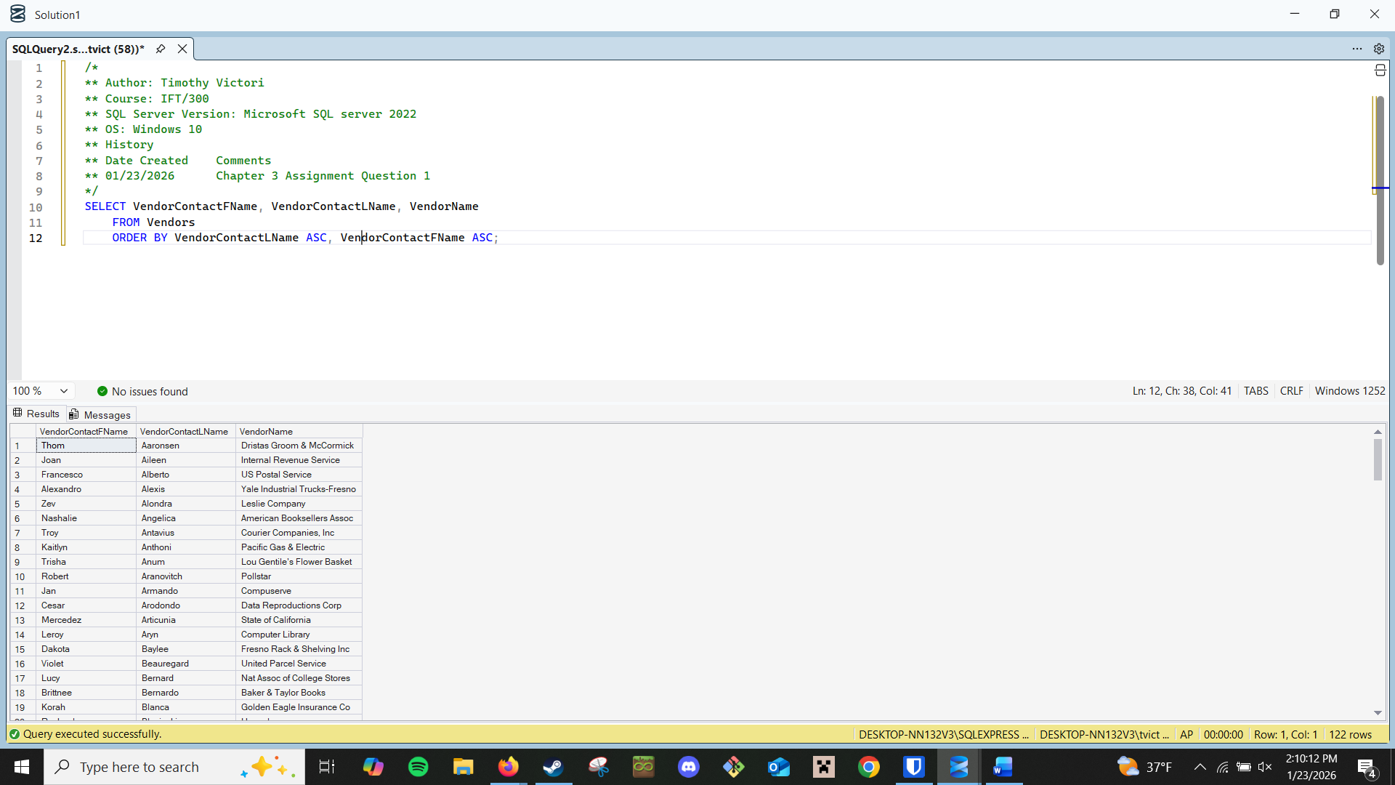
- Write a SELECT statement that returns four columns from the Invoices table, named Number, Total, Credits, and Balance:
Number Column alias for the InvoiceNumber column
Total Column alias for the InvoiceTotal column
Credits Sum of the PaymentTotal and CreditTotal columns
Balance InvoiceTotal minus the sum of PaymentTotal and CreditTotal
Use the AS keyword to assign column aliases.
  - 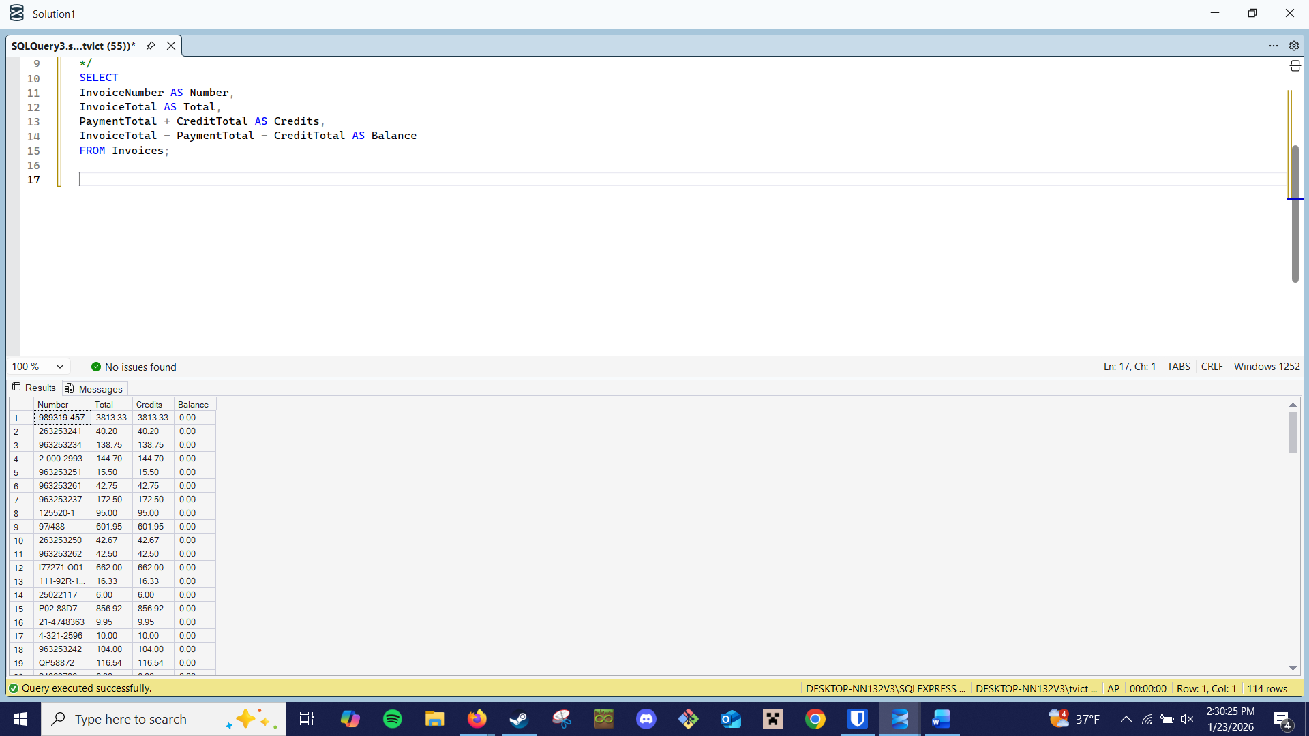
- Write a SELECT statement that returns one column from the Vendors table named Full Name. Create this column from the VendorContactFName and VendorContactLName columns. Format it as follows: last name, comma, first name (for example, “Doe, John”). Sort the result set by last name, then by first name.
  - 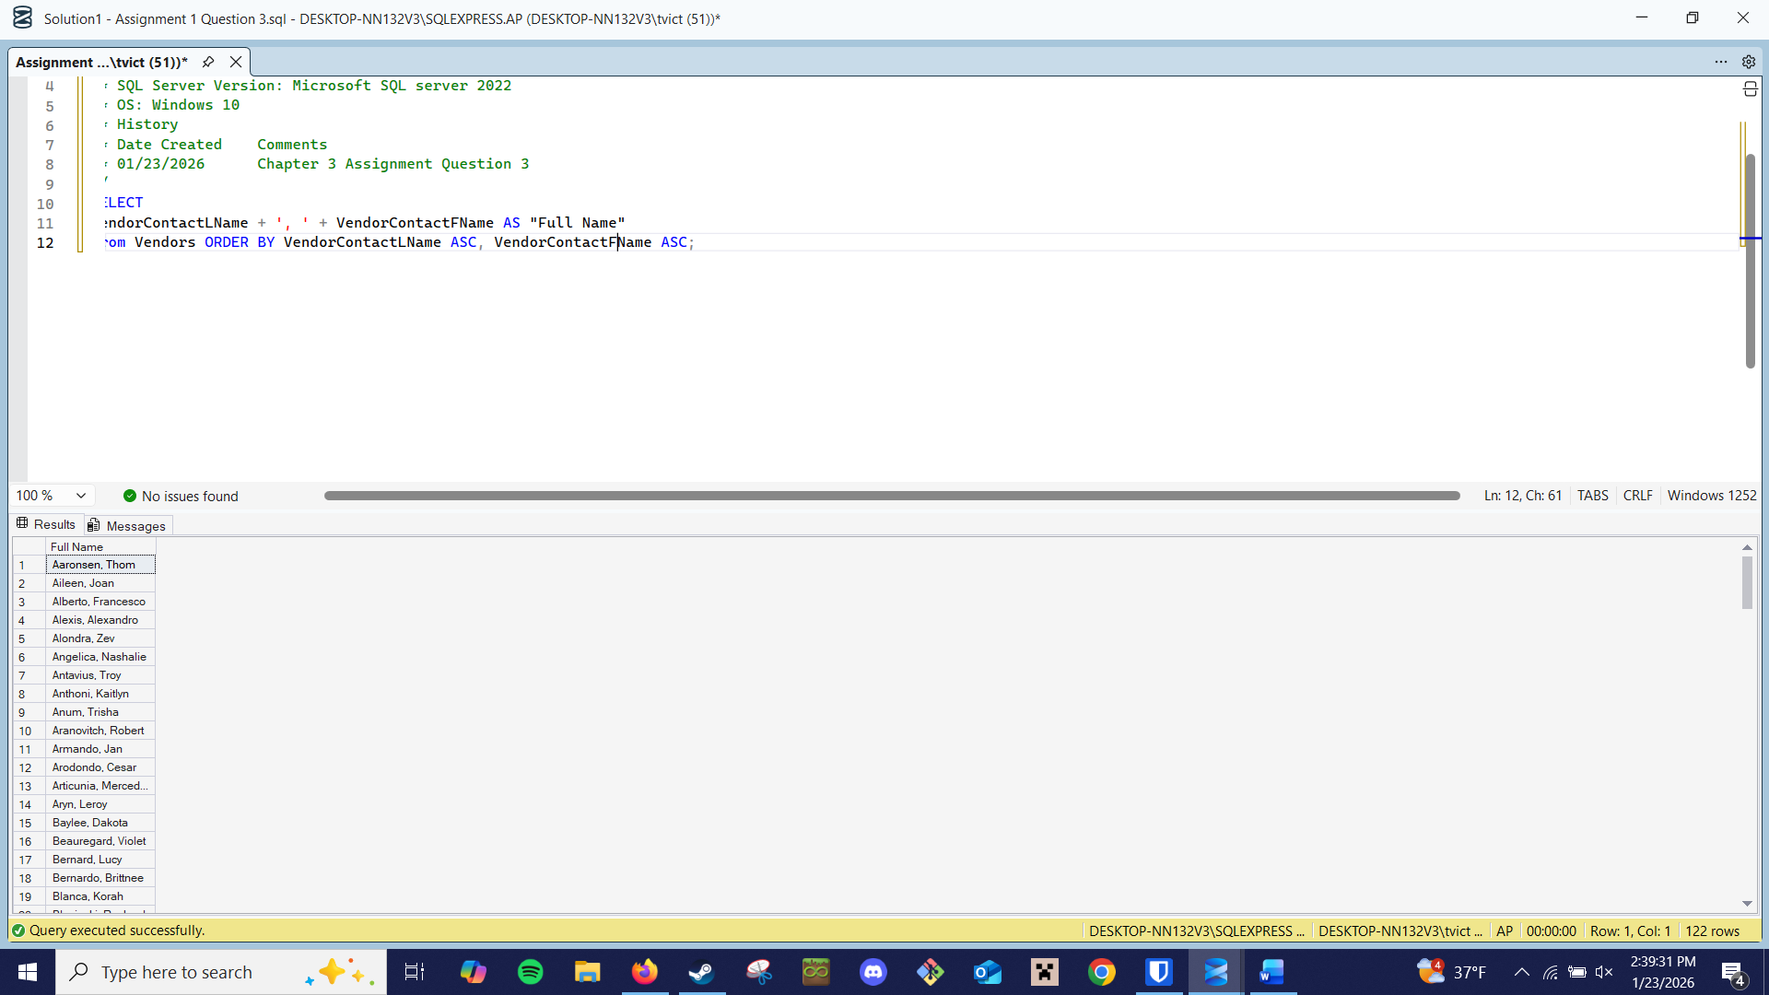
- Write a SELECT statement that returns three columns:
InvoiceTotal From the Invoices table
10% 10% of the value of InvoiceTotal
Plus 10% The value of InvoiceTotal plus 10%
(For example, if InvoiceTotal is 100, 10% is 10, and Plus 10% is 110.) Only return those rows with a
balance due greater than 1000. Sort the result set by InvoiceTotal, with the largest invoice first.
  - 